PDS Assignment-3

Hari chandra prasad Pasupuleti

16341883

a) set a seed (to ensure work reproducibility) and take a random sample of 25 observations and

find the mean Glucose and highest Glucose values of this sample and compare these statistics

with the population statistics of the same variable. You should use charts for this comparison.

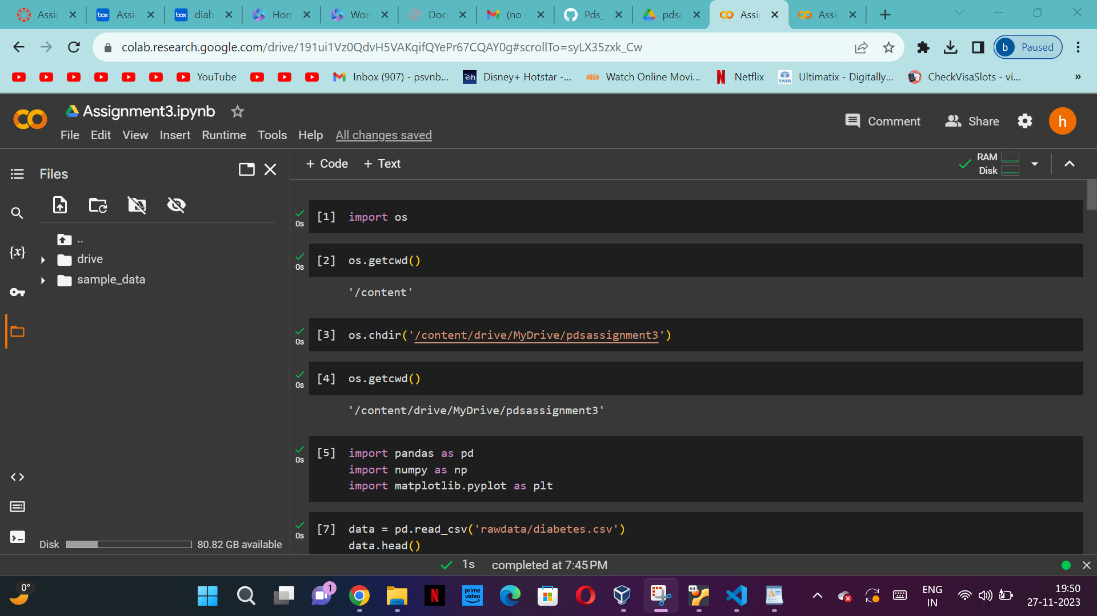

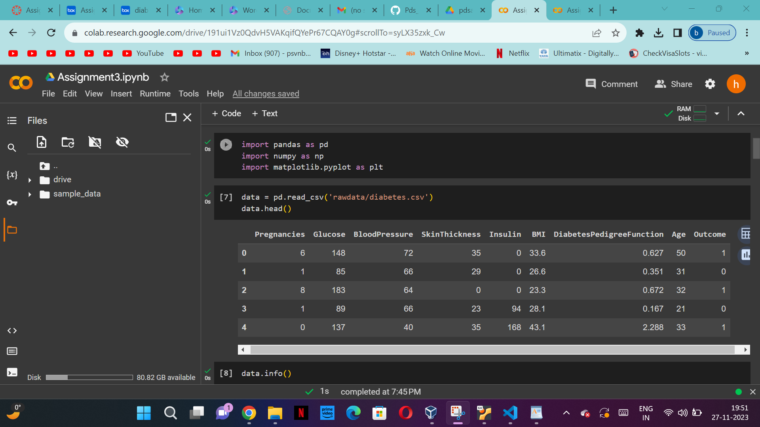

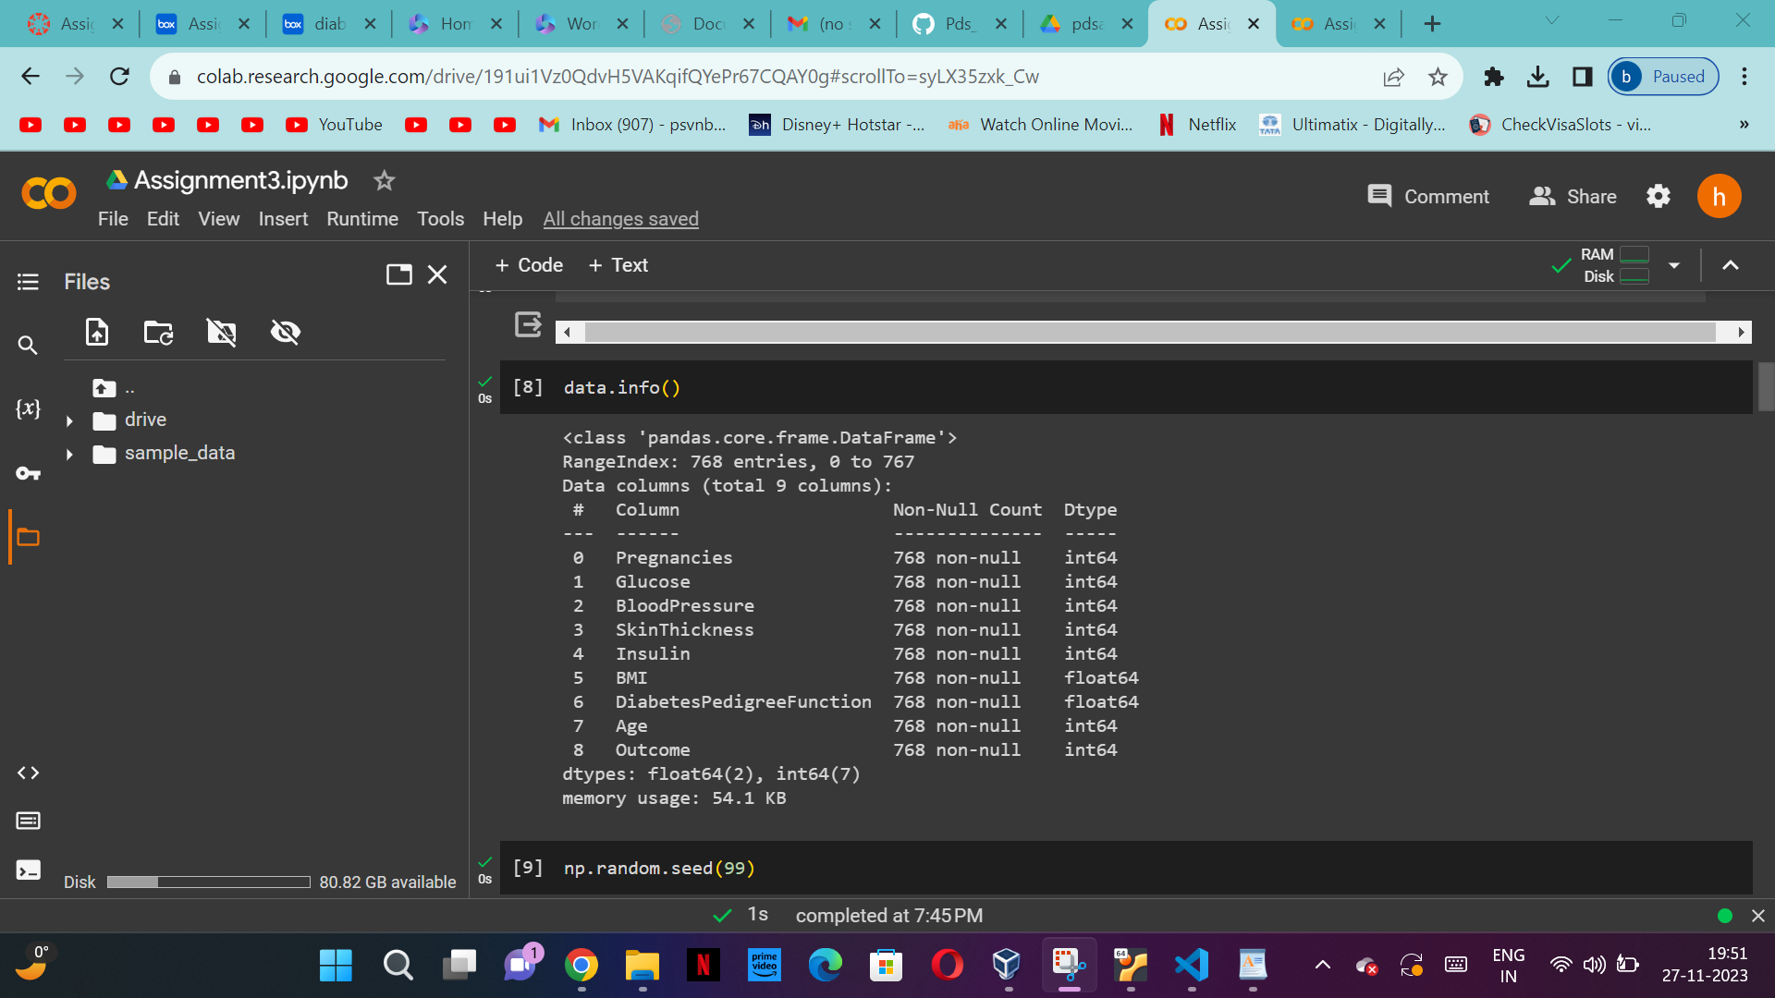

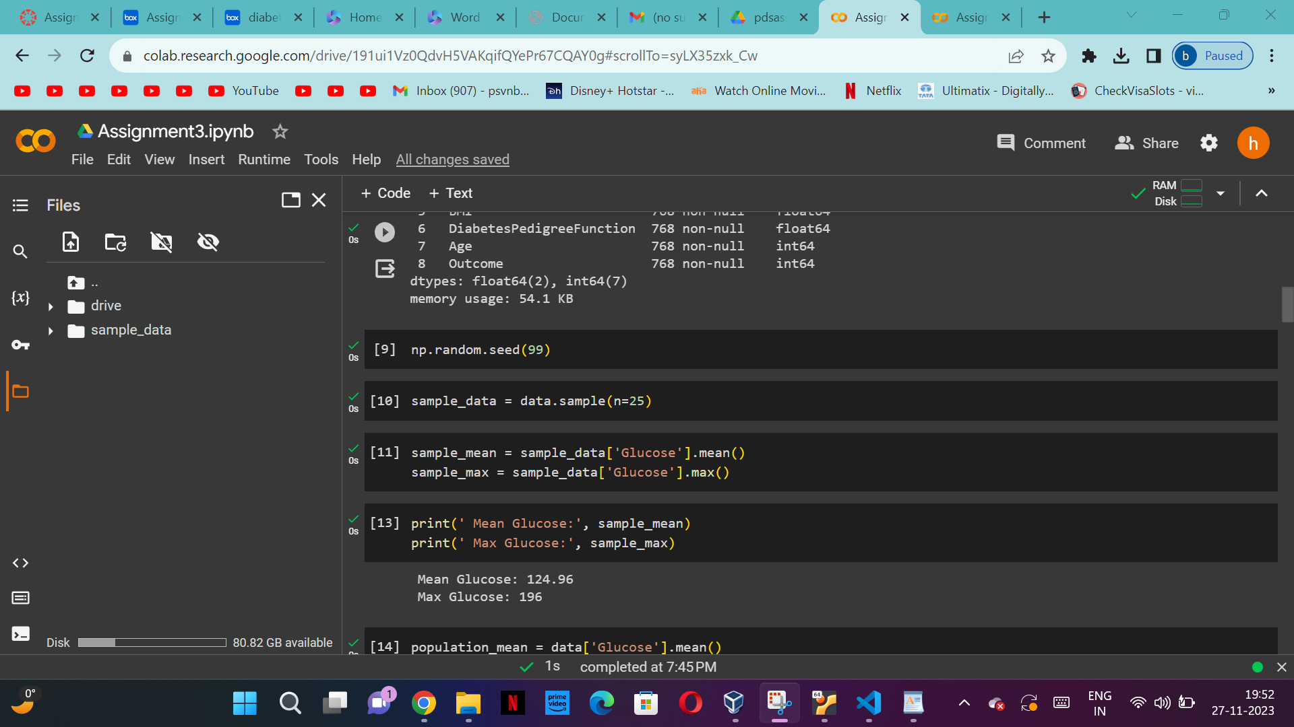

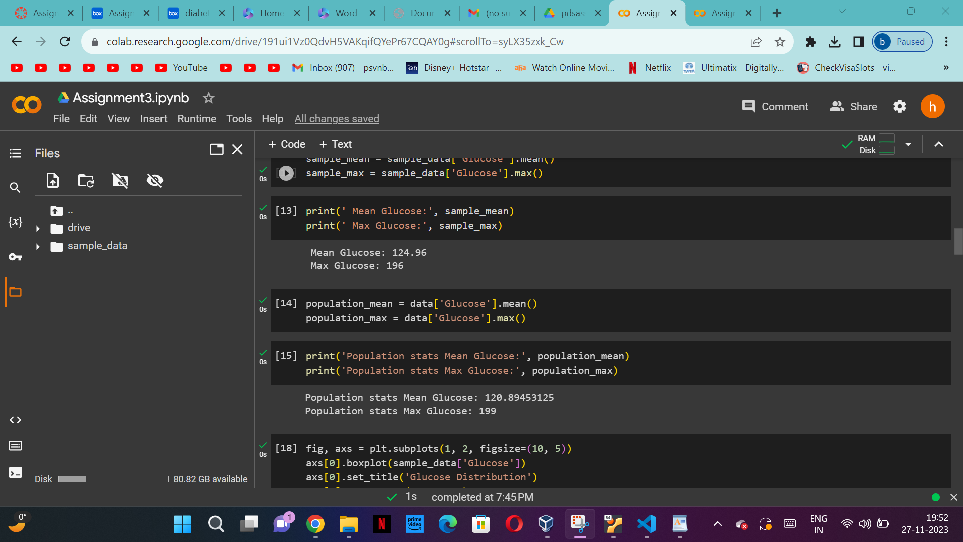

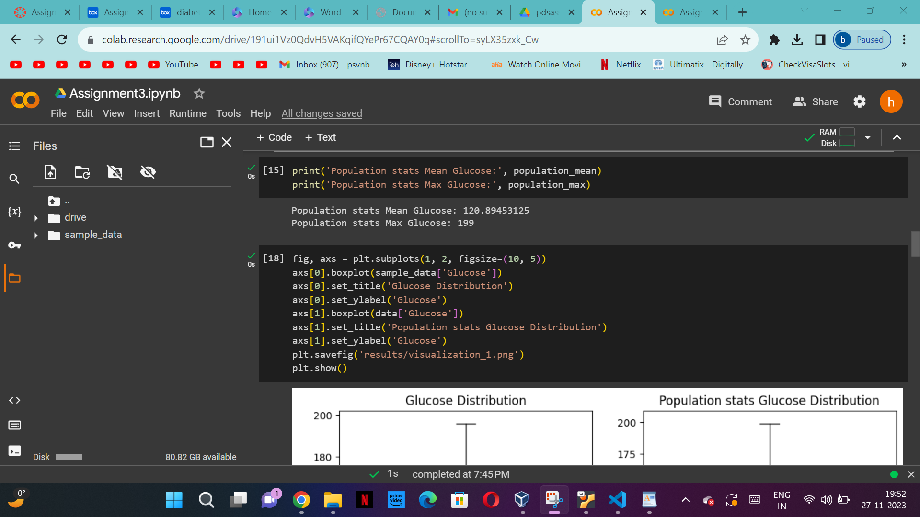

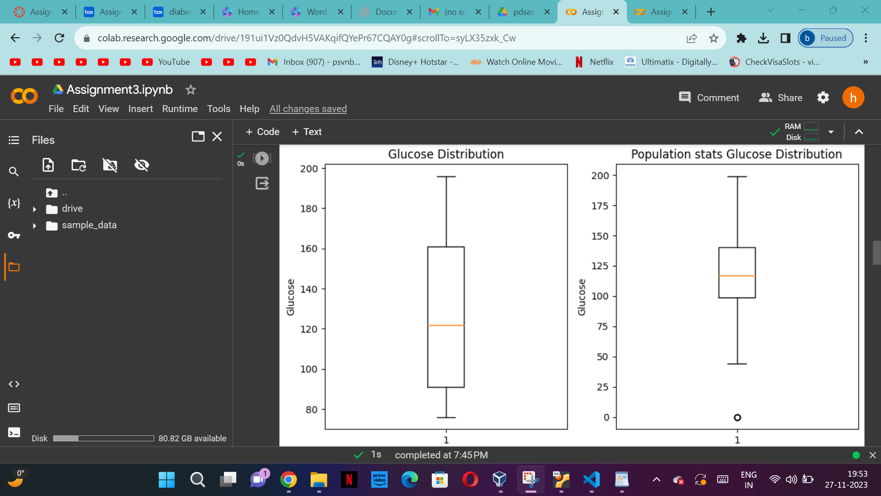

b) Find the 98th percentile of BMI of your sample and the population and compare the results

using charts.

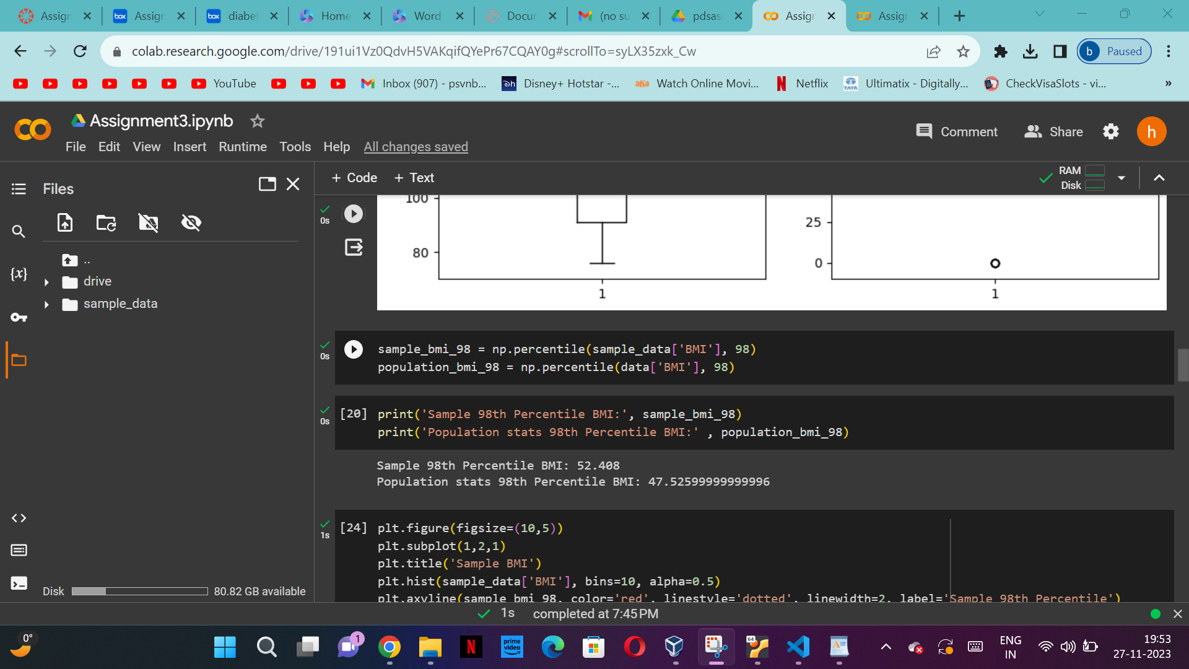

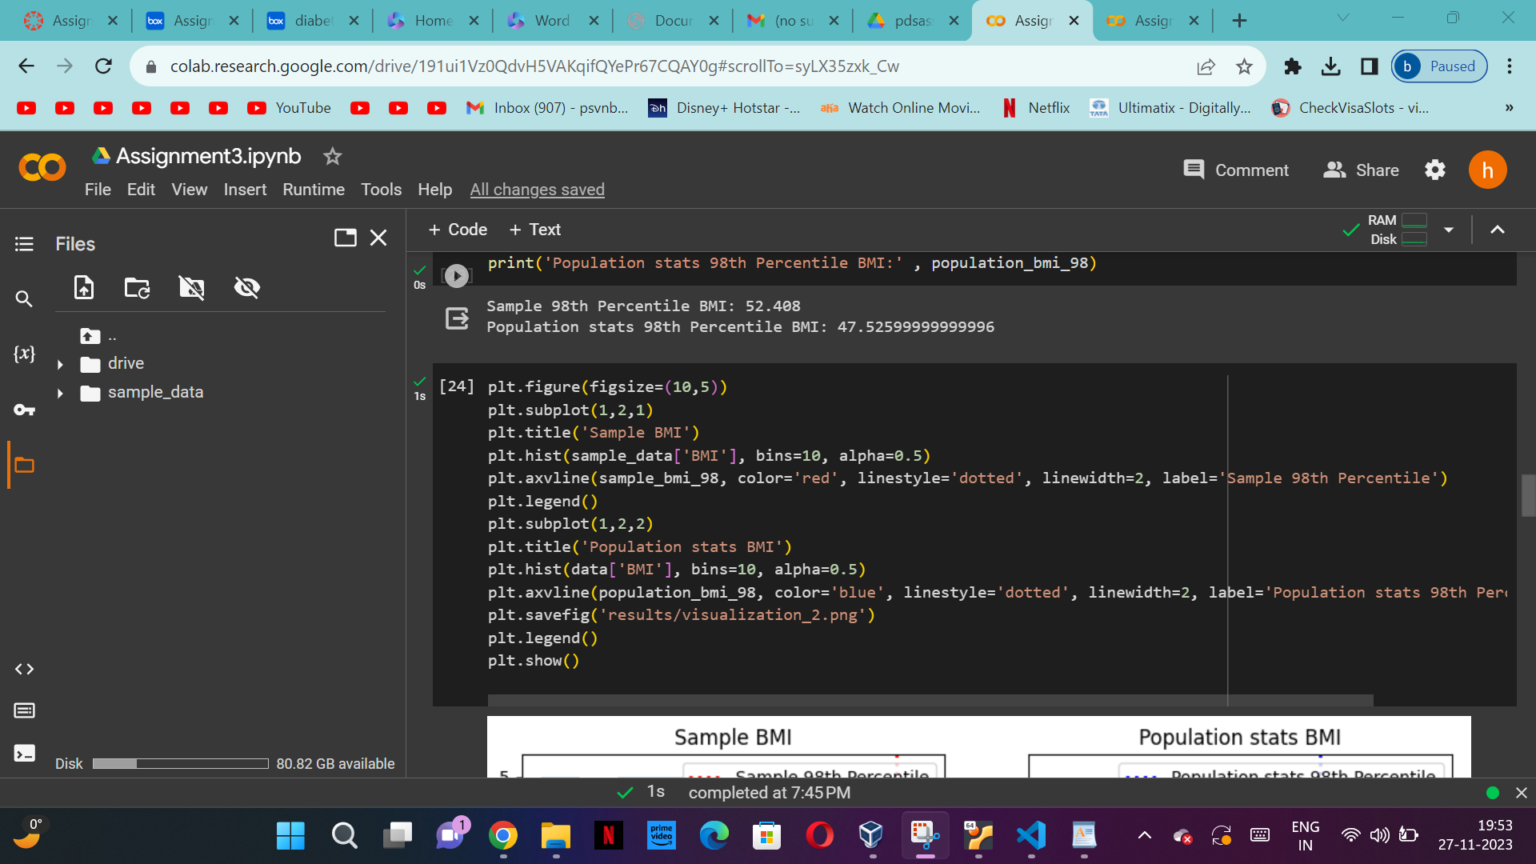

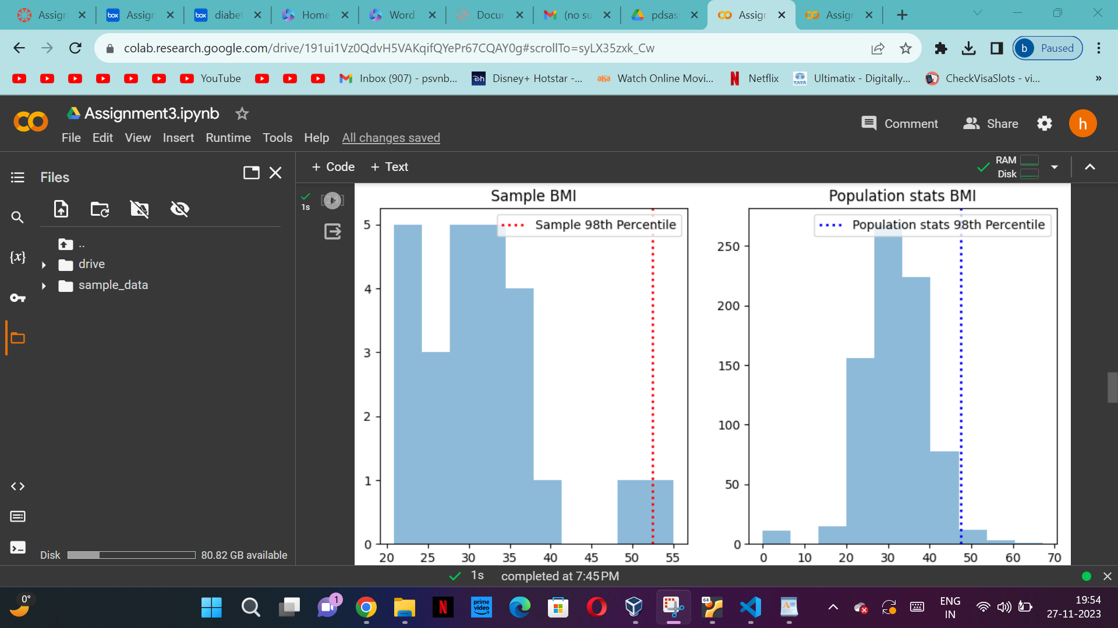

c) Using bootstrap (replace= True), create 500 samples (of 150 observation each) from the

population and find the average mean, standard deviation and percentile for Blood Pressure and

compare this with these statistics from the population for the same variable. Again, you should

create charts for this comparison. Report on your findings.

